OBJECTIVE:
- Understanding the operating modes of a timer:
- Understanding how to use a timer for creating delays and generating pulses.

REFERENCES:
- Lab manual Chapter 4, 5
- Atmel-2505-Setup-and-Use-of-AVR-Timers_ApplicationNote_AVR130.pdf

EXPERIMENT 1:
- Write a delay subroutine of 1 ms using Timer 0. Use this subroutine to generate a 500 Hz pulse on pin PA0.
- Simulate and modify the program to achieve accurate pulse generation.
- Connect pin PA0 to an oscilloscope to verify.

EXPERIMENT 2:
- Write a program to generate a 64 us square wave using Timer 0 in Normal mode. Use pin OC0 as the output.
- Write a program to generate a 64 us square wave using Timer 1 in CTC mode. Use pin OC0 as the output.
- Connect pin OC0 to an oscilloscope and observe.

EXPERIMENT 3:
- Given the program for generating two PWM pulses on OC0A and OC0B, connect pins OC0A and OC0B to two oscilloscope channels, measure and record the waveform, and explain the obtained waveform.
.org 00
call initTimer0
start:
rjmp start
initTimer0:
// Set OC0A (PB3) and OC0B (PB4) pins as outputs
ldi r16, (1 << PB3) | (1 << PB4);
out DDRB,r16
ldi r16, (1 << COM0B1)|(1 << COM0A1) | (1 << WGM00)|(1 << WGM01)
out TCCR0A,r16 // setup TCCR0A
ldi r16, (1 << CS01)
out TCCR0B,r16 // setup TCCR0B
ldi r16, 100
out OCR0A,r16 //OCRA = 100
ldi r16, 75
out OCR0B,r16 //OCRB = 75
ret

EXPERIMENT 4:
- Modify the program for different combinations of TCCR0A and TCCR0B registers as described in the table:
 | TCCR0A |  |  |  |  |  |  |  | TCCR0B
 | 7 | 6 | 5 | 4 | 3 | 2 | 1 | 0 | 7 | 6 | 5 | 4 | 3 | 2 | 1 | 0
1 | COM0A1 | COM0A0 | COM0B1 | COM0B0 |  |  | WGM01 | WGM00 | FOC0A | FOC0B |  |  | WGM02 | CS02 | CS01 | CS00
2 | 1 | 0 | 1 | 0 |  |  | 1 | 1 |  |  |  |  | 0 | 0 | 1 | 0
3 | 1 | 0 | 1 | 0 |  |  | 1 | 1 |  |  |  |  | 1 | 0 | 1 | 0
4 | 1 | 0 | 1 | 0 |  |  | 0 | 1 |  |  |  |  | 0 | 0 | 1 | 0
- Connect pins OC0A and OC0B to two oscilloscope channels, measure and record the waveforms, and explain the obtained results.

EXPERIMENT 5:
- Write a program to generate a 1 kHz square wave with a duty cycle of 25% on pin OC0B.
- Connect to an oscilloscope and measure the output waveform.
- Connect OC0B to the R channel of an RGB LED. Write a program to increase the duty cycle on OC0B from 0% to 100% and then decrease it back to 0% over 10 ms, with a 1% increment.

EXPERIMENT 1:
- Answer the following questions:
  - What is the maximum delay achievable using Timer 0 with an 8 MHz frequency? Explain the calculation.
  - What is the maximum delay achievable using Timer 1 with an 8 MHz frequency? Explain the calculation.
  - Explain how to calculate the prescaler values and the values loaded into Timer0 registers for this experiment.
  - Source code for the program with comments.
/*XTAL is 8MHz, we scale down 64*/
LDI R16,(1<<0) ;SET BIT 0
SBI DDRA,0
LDI R17,0
OUT PORTA,R17
LDI R20,124 ;STORE 124 INTO OCR0A
OUT OCR0A,R20
Delay1ms:
LDI R20,0x02 ;SET WGM01 ON
OUT TCCR0A,R20
LDI R20,0x03 ;SET CSO1 AND CSO2
OUT TCCR0B,R20
AGAIN:
SBIS TIFR0,OCF0A
RJMP AGAIN

LDI R20,0x0
OUT TCCR0B,R20
LDI R20,1<<OCF0A
OUT TIFR0,R20

EOR R17,R16
OUT PORTA,R17
RJMP Delay1ms

EXPERIMENT 2:
- Answer the following questions:
  - In Normal mode, when is the TOVx bit set to 1?
  - In CTC mode, when is the OCFx bit set to 1?
  - Provide the register configurations for Timer 0 for both cases.
  - Source code for the programs in both cases.
CASE 1:
/*XTAL is 8MHz, we scale down 64*/
LDI R20, 0xFF
OUT OCR0A, R20
SBI DDRB, 3
DELAY:
LDI R20,0xF8 ;
OUT TCNT0,R20
LDI R20,0x40 ;SET WGM01 ON
OUT TCCR0A,R20
LDI R20,0x03 ;SET CSO1 AND CSO2
OUT TCCR0B,R20
AGAIN:
SBIS TIFR0,TOV0
RJMP AGAIN

LDI R20,0x0
OUT TCCR0B,R20
LDI R20,1<<TOV0
OUT TIFR0,R20
RJMP DELAY
CASE 2:

EXPERIMENT 3:
- Answer the following questions:
  - Describe the waveform on the oscilloscope (capture and insert it).
  - Explain the reasons for the observed waveform (frequency, duty cycle, phase).
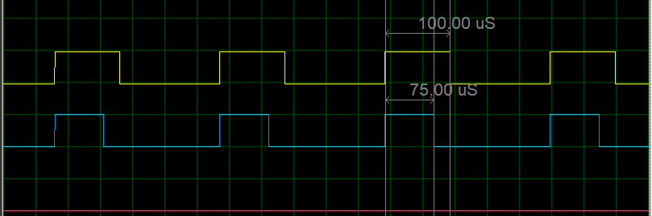

EXPERIMENT 4:
- Answer the following questions:
  - Identify the working modes of Timer 0 corresponding to the values in the table.
- Capture images of the waveforms corresponding to the different working modes and explain the results.

EXPERIMENT 5:
- Answer the following questions:
  - In which mode is Timer 0 operating?
  - What values are loaded into Timer 0 registers, and why?
- Present the source code with comments.
........................................................................................................................

